This matter is being dealt with by:
Janie Goodman
T 0115 9772448
E janie.goodman@nottscc.gov.uk
W nottinghamshire.gov.uk

Dear Head Teacher, 2 December 2015

Nottinghamshire County Council Home to School and Post 16 Transport – Public Consultation

I am writing to inform you that Nottinghamshire County Council is consulting on proposals to cease the provision of discretionary travel services to schools, colleges and other educational establishments in Nottinghamshire from September 2018.

Under the proposals the statutory entitlements of children and young people will continue to be protected. Children and young people attending their qualifying (catchment) school living beyond the statutory walking distance will continue to qualify for travel assistance from the Local Authority.

Children from low income families have extended rights to free travel which will be protected. For primary age pupils this is a reduction in the statutory walking distance and for secondary age pupils travel assistance will be provided to one of the three nearest qualifying schools (catchment or preferred) between two and six miles from home. For low income children attending their nearest suitable school preferred on grounds of faith, they will receive free travel where the school is between 2 and 20 miles (primary) or 2 and 25 miles (secondary) from their home.

The financial challenge facing Nottinghamshire County Council is significant and some difficult decisions will be needed to help us balance the budget. Over the next three years we are facing a budget shortfall of £62m.

Nottinghamshire along with many other local authorities is having to make difficult decisions regarding the services they offer. Protecting services that are statutory unfortunately means that many discretional services may have to be reduced or ceased. Increasingly the trend over recent years is for councils across the country to review their expenditure and to critically assess the affordability of all services.

You can view this and all of our budget proposals on the Nottinghamshire County Council website at www.nottinghamshire.gov.uk/budget.

These are just proposals at this stage and you can have your say by visiting nottinghamshire.gov.uk/budget, phoning 0300 500 80 80 or responding to copies of consultation documents in any County Council library. We value responses from all stakeholders to this and would be grateful if you could alert parents, staff and governors through your usual communication channels.

The budget consultation starts on 9 December, 2015, and will close on 5 February, 2016. Final decisions will be made by elected members at Full Council on 25 February, 2016.

Yours sincerely

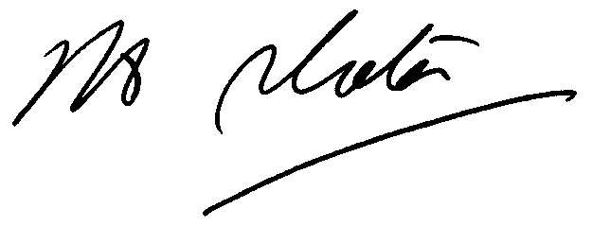

John Slater
Service Director for Education, Standards and Inclusion
Children, Families and Cultural Services
Nottinghamshire County Council

